Navigate to <http://13.127.11.167/static/images/> to get all the images .

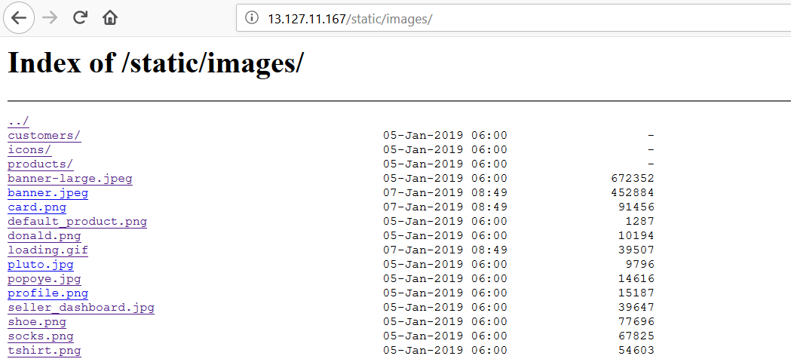

Also a hidden CMS is shown in the directory listing.

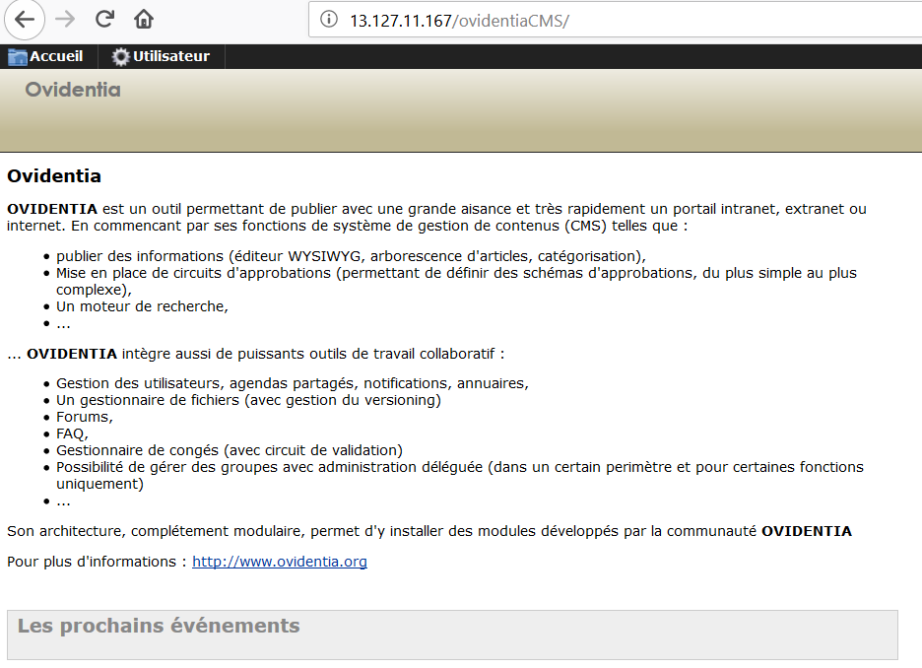

Navigate to <http://13.127.11.167/static/images/uploads/> to get other folders containing images.

